D&H Laser Etch Form
Please select from the following options below.
Pricing scales with size of etch. Standard size 2”x3.5” Large 4”x4”
Size of Etch: Standard☐ Large☐ Custom☐
If custom, please specify: Click here to enter size.
Type of Etch: Logo ☐ Text ☐ Both ☐
**Please attach a jpeg/pdf of the desired logo**

If text is needed: Click here to enter text.

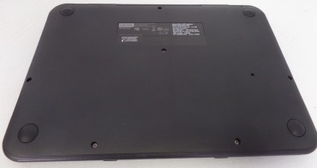
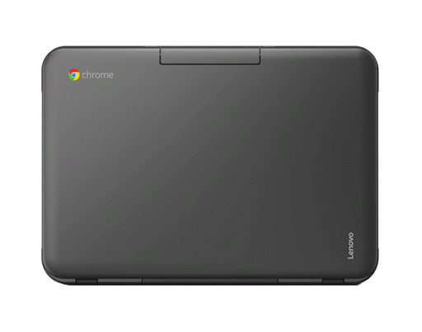
Placement of Etch: Top☐ Bottom☐
*requested placement may not be possible depending on model & existing branding
Specific location: (check one)
☐ ☐ ☐
☐ ☐ ☐ ☐

