D&H Chromebook White Glove

Required Information

Account Name
D&H Account Number
D&H Sales Rep
Account Point of Contact

Deployment Checklist (leave blank if no preference, Red is required) Response

Customer Domain/Google Apps Domain name
QTY Number of Chromebooks to prepare with these instructions
Desired date to receive shipment.
This will be used as a best effort guideline. We can present you with an ETA prior to ordering if requested.
AutoUpdate* Preform full update to latest stable channel release version at time of prep. | Included in WG Price
Enterprise Enrollment – Perform enrollment to register Chromebook for  Enterprise Management. | Included in WG Price
QA Enrollment check - Final check of enrollments at the serial# level within the admin console to confirm project qty match | Included only when admin access is granted*
Enterprise Enrollment ID –Test Acct. Desired
Google Apps Account used for enrollment. This should be a dedicated role account or test account such as enroll@domain.com we just need the ability to authenticate with Google.
Password – Temporary password for enterprise enrollment ID (this can be changed later)
Account Confirmation * Please verify that the account provided for enrollment is tested and working. an incorrect entry will cause delays to your order.

Asset tagging? (If yes, the Asset tag  Details must be provided separately on PG3) | (optional) Additional cost. Please contact your rep for more information
Laser Etching? (If yes, the Etch details must be provided separately on PG4) | (optional) Additional cost. Please contact your rep for more information
Additional deployment steps?  Green shipping- OU Move - OU data population or further customization | (optional) Additional cost. Please contact your rep for more information

Optional Wi-Fi Pre-Configuration
(Not required if WiFi credentials are already in your admin console)

Wireless Config – Preform WiFi
Configuration. This is only available
for WEP, WPAPSK, or WPA2PSK
networks (please specify AES orTKIP)
WiFi SSID Your network’s SSID
(WARNING: This is case sensitive)
Choose WiFi Security Type
PreShared Key
(Warning: This is case sensitive)

*Device level admin access is required in order to quality check projects within the admin console and/or populate tag data, OU moves etc. Upon request we can share device ID info with the domains admin to confirm counts are correct prior to shipping and this process may delay your order

Additional Instruction:

Asset Tag Form
Asset tag info, 1x2 Thermal/mono Poly tags. Smudge resistant & highly durable.

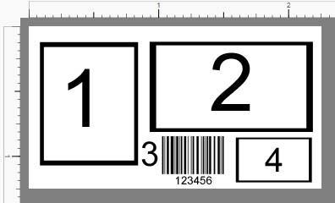
There are 4 commonly requested fields on most asset tag projects, please attach/fill out those fields below and submit with your order. Thank you
How Many Tags Are Required? ___
- LOGO. Attach via e-mail or Provide URL –

- ADDRESS (if you would like this area to start with “property of” please indicate) –

- BARCODE (optional) attach data via CSV, Access, Excel, Text, ETC. or simply
- Indicate a range from 1xxxx to 15xxxx as an example. –

- Optional field. Typically reserved for information such as “if found please contact etc.”
Additional Instruction:

Laser Etch Form
Please select from the following options below.
- Pricing scales with size of etch. Standard size 2”x3.5” Large 4”x4”
  - A design mockup will be provided for approval
- Size of Etch: Standard☐ Large☐ Custom☐
  - If custom, please specify:
- Type of Etch: Logo ☐Text ☐ Both ☐
- **Please attach a jpeg/pdf of the desired logo**
- If text is needed, please add messaging:
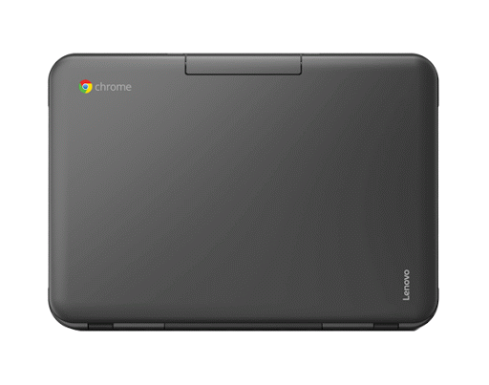
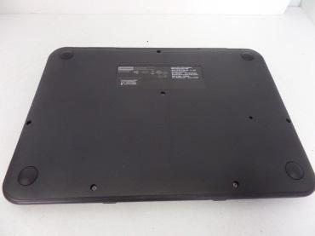
Placement of Etch (check one):
TOP
☐
Bottom
☐

Specific location: (check one)
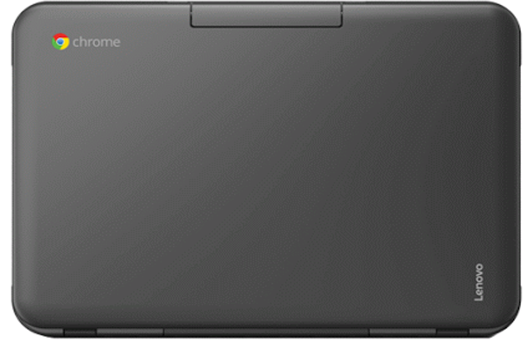
☐
☐
☐
☐
☐
☐
☐
☐
☐
*requested placement may not be possible depending on model & existing branding
Additional Instruction:

